Chapter 1 : Introduction Of System

1.1 Problem Statement

Event planning and management is a complex process that requires coordination of various services such as venue booking, catering, decoration, and scheduling. Traditional event management methods rely on manual processes, phone calls, and physical booking systems, which are time-consuming, inefficient, and prone to errors.

There is a need for an automated system that allows users to explore event packages, view details, and book events easily from a single platform. The system should also manage user registration, event packages, and booking information efficiently.

The proposed Event Management System (Momento) provides a digital platform that simplifies event planning by offering event packages, booking functionality, and centralized management.

The proposed solution is a web-based Event Management System that provides:
- Online event browsing
- Event package selection
- User registration and login
- Package details viewing
- Event booking functionality
- Centralized database management

1.2 Solution for Problem Statement

The proposed solution is a web-based Event Management System that provides:
- Online event browsing
- Event package selection
- User registration and login
- Package details viewing
- Event booking functionality
- Centralized database management
- Make a custom Event
The system reduces manual work and provides a simple and efficient way to manage events.

1.3 Proposed Solution

The proposed system is a web-based platform that provides:
- Online event package browsing
- User authentication and registration
- Package details with images and catering information
- Event booking functionality
- Centralized data storage
- Secure backend services
The system reduces manual work and improves efficiency by digitizing the event management process.

1.4 Objectives of the System

The main objectives of the Event Management System are:
- To provide an online event booking platform
- To simplify event package selection
- To manage user accounts securely
- To maintain centralized database of events and users
- To provide easy access to event information
- To reduce manual workload in event planning
- To improve user experience using modern UI design

1.5 System Scope

The scope of the system includes:
- User registration and login
- Viewing event packages
- Viewing package details
- Event booking functionality
- Data storage in MongoDB database
- Backend API integration
- Authentication
- Verify Register User

Future Scope
- Online payment integration
- Admin dashboard
- Email notifications
- Event scheduling management

1.6 System Limitations

- No payment gateway integration
- No advanced admin panel
- Limited booking management
- No event cancellation feature
- No notification system
- No multi-user role management

Acknowledgement

It is my privilege to express my sincere gratitude to the individuals who helped me, directly or indirectly, in conducting this project work. I would like to thank Uka Tarsadia University for including this project work activity in the M.C.A. curriculum.

I am deeply grateful to our Director, Dr. Dharmendra Bhatti, and my project guide, Shivani Patel Ma’am for providing the valuable guidance and suggestions necessary for the successful completion of this project. I am also indebted to all the respondents, whose cooperation made this project possible.

Finally, I extend my special thanks to every faculty member of the Shrimad Rajchandra Institute of Management and Computer Application (SRIMCA), as well as my friends and family, for their constant support throughout this endeavour.

1.7 Tools and Technologies Used
Frontend Technologies
- React.js — Component-based UI development
- HTML5 — Page structure
- CSS3 — Styling and layout
- JavaScript — Dynamic functionality
Backend Technologies
- Node.js — Server runtime environment
- Express.js — REST API framework
Database
- MongoDB — NoSQL document-based database
- Mongoose — MongoDB object modeling
Development Tools
- Visual Studio Code
- Thunder Client API testing
- GitHub version control

CHAPTER 2 — SYSTEM REQUIREMENTS
2.1 Functional Requirements
User Management
- User registration
- User login authentication
- Password encryption
- Session handling
Event Management
- View event packages
- View package details
- Display package images
- Display catering services
Booking Management
- Book selected event
- Store booking details
- Associate booking with user
Database Management
- Store user records
- Store Event Packages
- Retrieve Data dynamically
2.4 Data Model Description

User Collection
Field | Description
fullname | Username
email | Unique Email
password | Encrypted Password
phone | Contact Number

Package Collection

Field | Description
name | Username
description | Package Detals
price | Price
images | Image of package
catrering | Food Service

Event Collection

Field | Description
title | Title of Event
description | Event Details
date | Events Date
location | Venue
image | Image of event

CHAPTER 3 — CONSEPTUAL DESIGN

Actors :
3.1 User
3.2 Admin

3.1 User

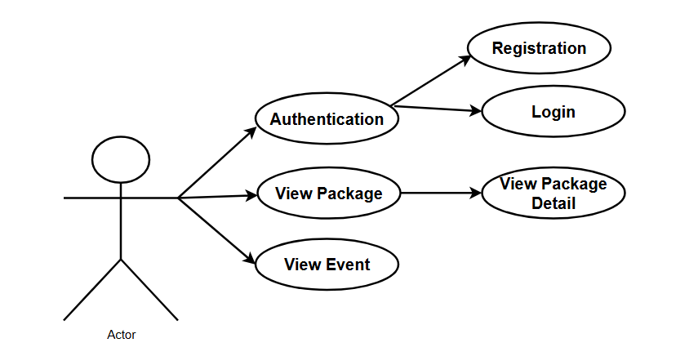

- User can Login but first he have to register through Registration Page
- User can View Packages .
- User also view Event that are recently organized by Momentoe.

3.2 Admin

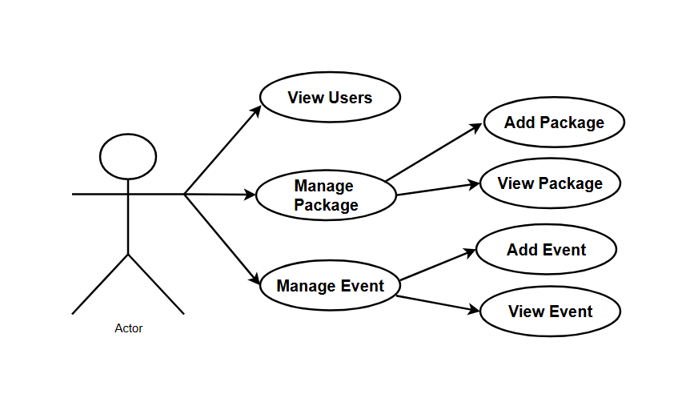

- Admin View Packages
- Admin View Events
- Admin View User
- Admin manage Events
- Admin manage Packages

CHAPTER 4 — SYSTEM DESIGN
4.1 Database Design

MongoDB Design Approach
- Document-based storage
- Flexible schema

Event Collection :
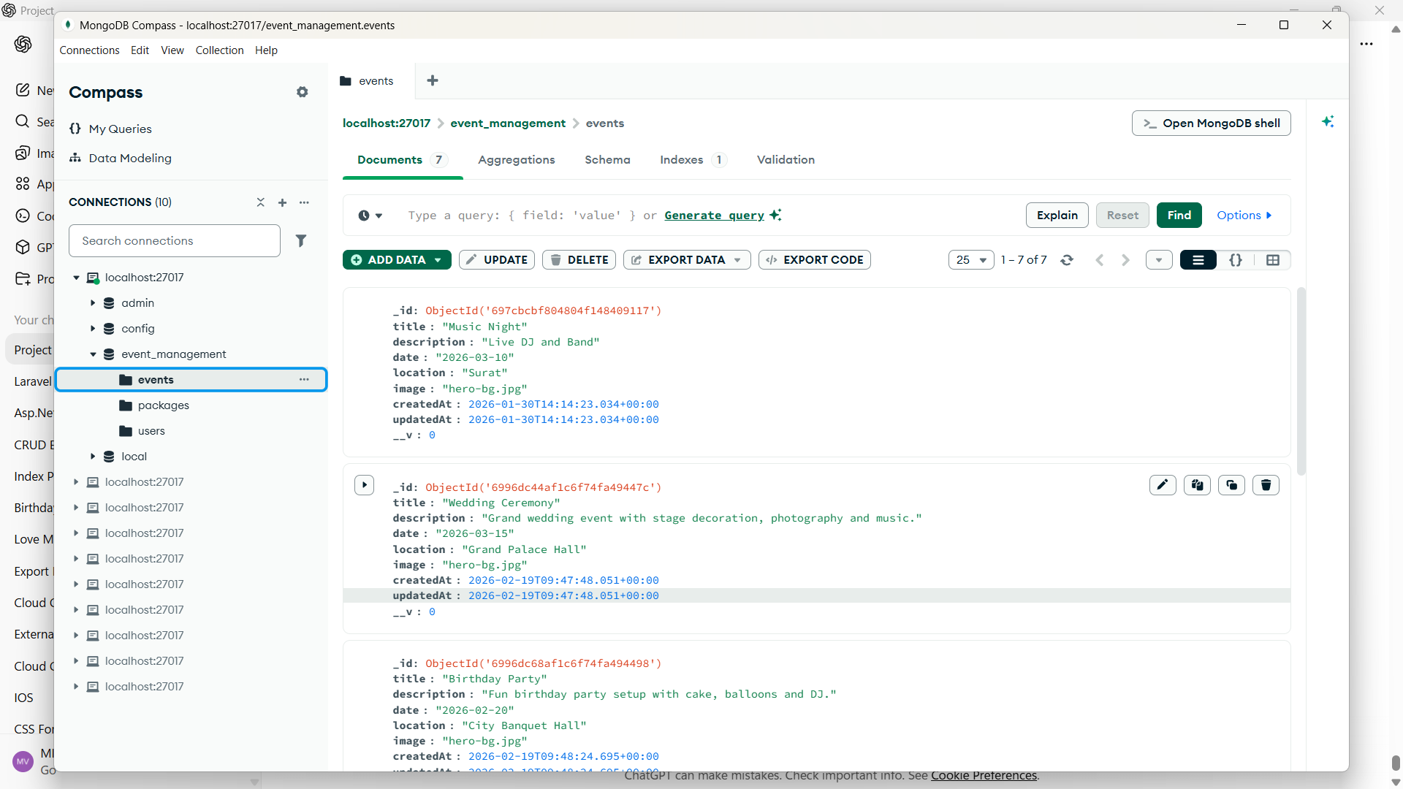

Package Collection :

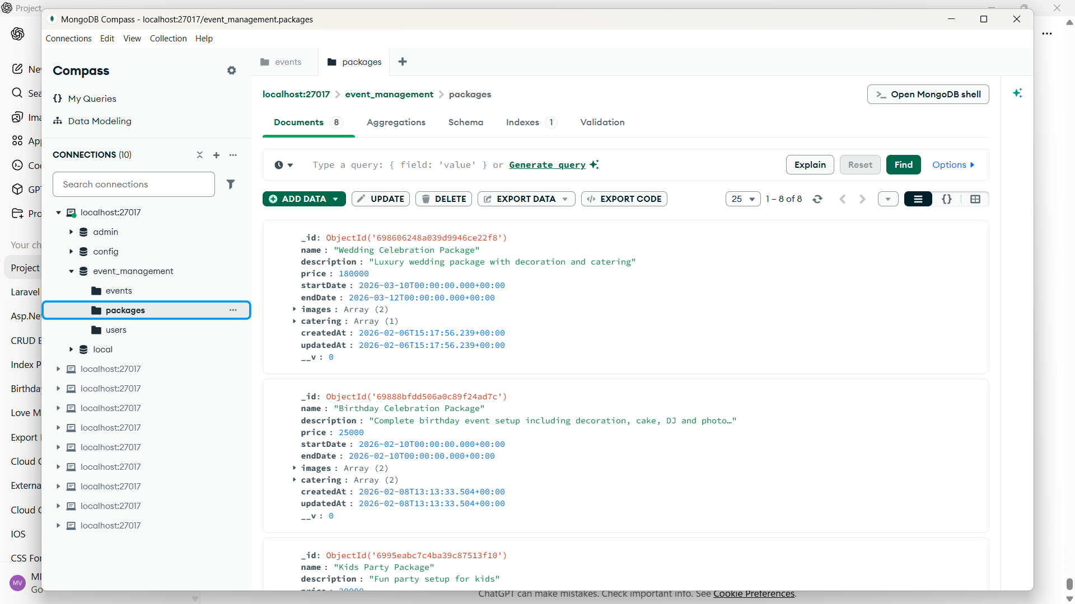

User Collection :

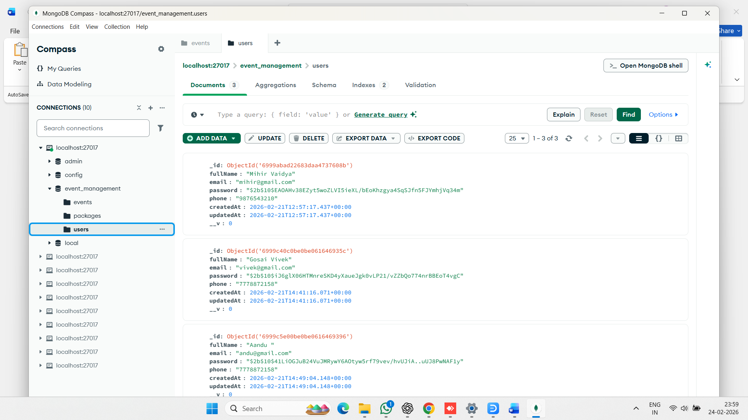

Event Document :

{
"_id": {
"$oid": "697cbcbf804804f148409117"
},
"title": "Music Night",
"description": "Live DJ and Band",
"date": "2026-03-10",
"location": "Surat",
"image": "hero-bg.jpg",
"createdAt": {
"$date": "2026-01-30T14:14:23.034Z"
},
"updatedAt": {
"$date": "2026-01-30T14:14:23.034Z"
},
"__v": 0
}

Package Collection Document :

{
"_id": {
"$oid": "698606248a039d9946ce22f8"
},
"name": "Wedding Celebration Package",
"description": "Luxury wedding package with decoration and catering",
"price": 180000,
"startDate": {
"$date": "2026-03-10T00:00:00.000Z"
},
"endDate": {
"$date": "2026-03-12T00:00:00.000Z"
},
"images": [
"hero-bg.jpg",
"hero-bg.jpg"
],
"catering": [
{
"thaliName": "Premium Wedding Thali",
"description": "Paneer, Dal Makhani, Butter Naan, Sweet",
"price": 1500,
"_id": {
"$oid": "698606248a039d9946ce22f9"
}
}
],
"createdAt": {
"$date": "2026-02-06T15:17:56.239Z"
},
"updatedAt": {
"$date": "2026-02-06T15:17:56.239Z"
},
"__v": 0
}

User Collection Document :

{
"_id": {
"$oid": "6999abad22683daa4737608b"
},
"fullName": "Mihir Vaidya",
"email": "mihir@gmail.com",
"password": "$2b$10$EAOAHv38EZyt5woZLVI5ieXL/bEoKhzgya4SqSJfn5FJYmhjVq34m",
"phone": "9876543210",
"createdAt": {
"$date": "2026-02-21T12:57:17.437Z"
},
"updatedAt": {
"$date": "2026-02-21T12:57:17.437Z"
},
"__v": 0
}

4.2 API Screenshots :
4.2.1 Events
4.2.2 packages
4.2.1 Events :
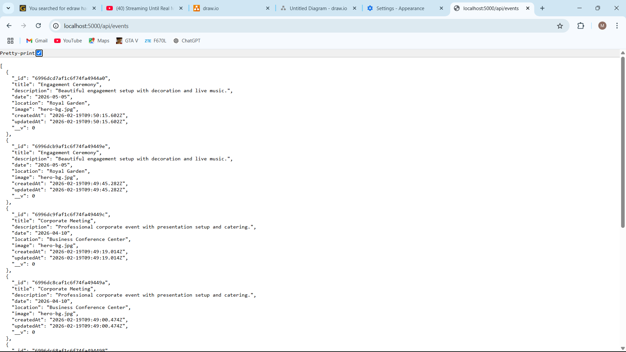

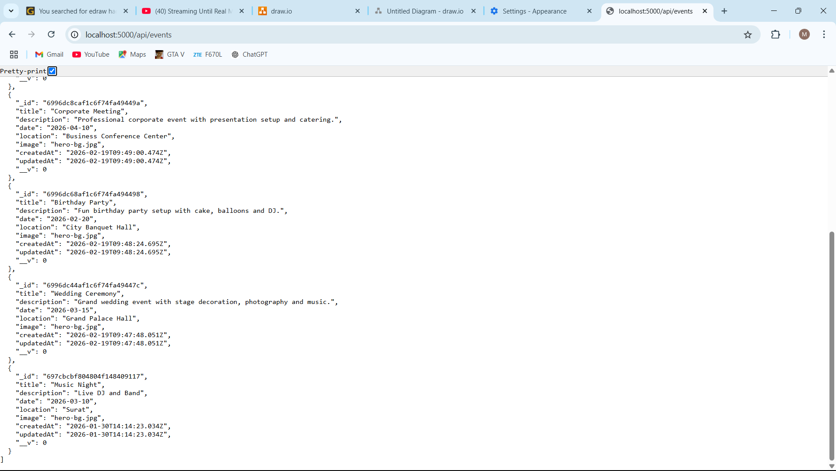

4.4.2 Packages :

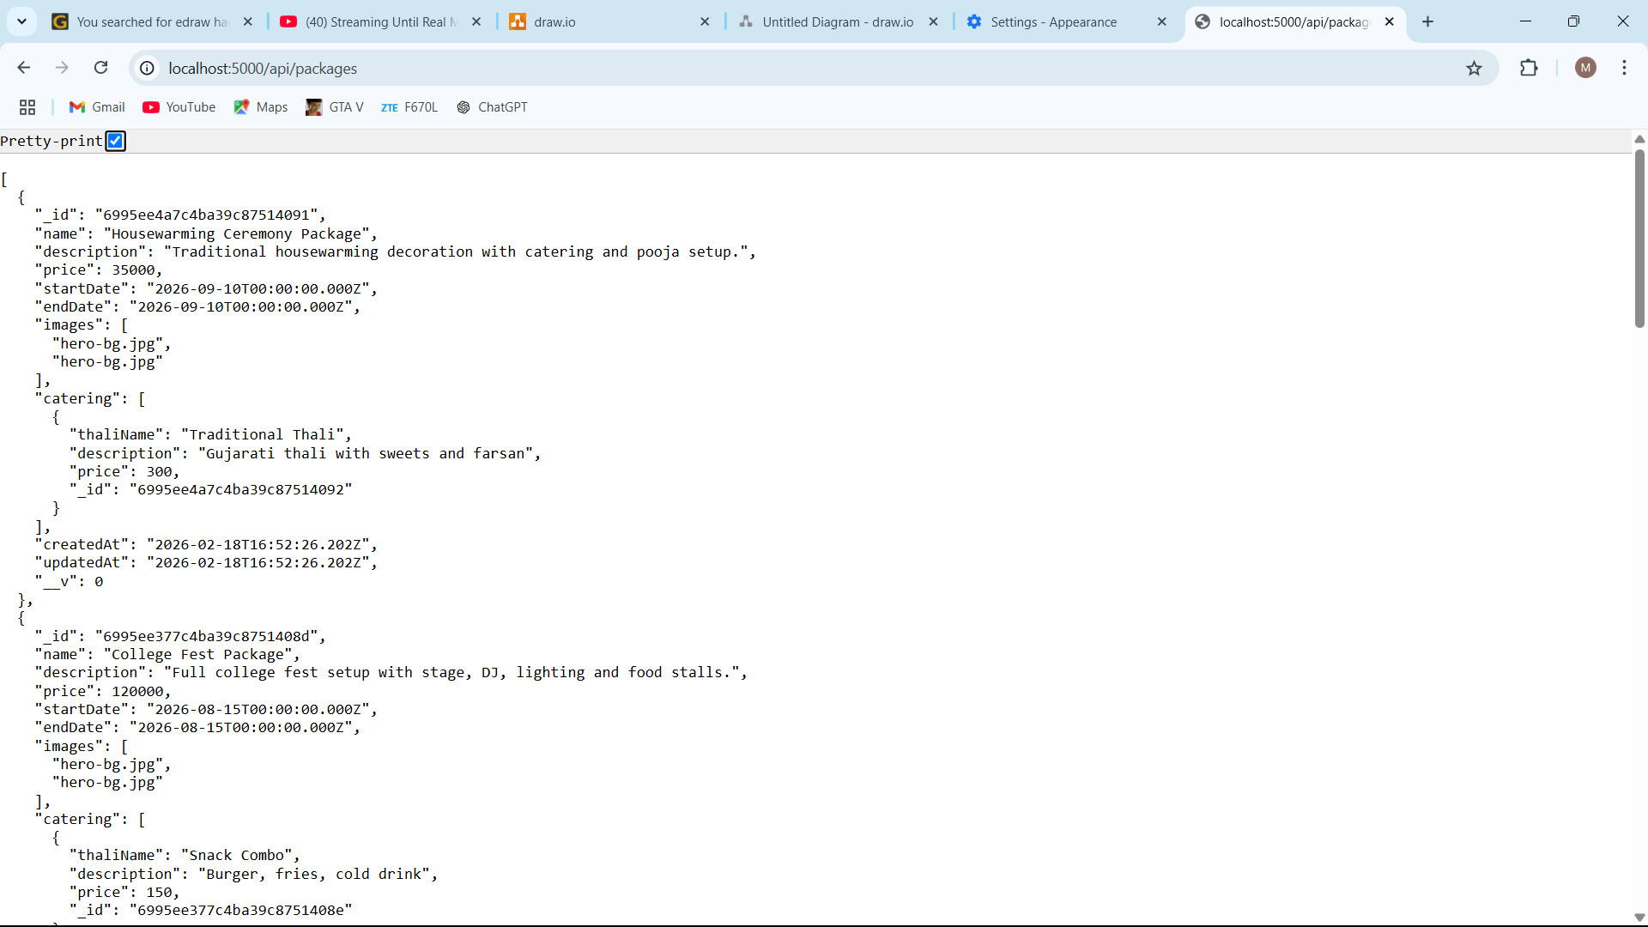

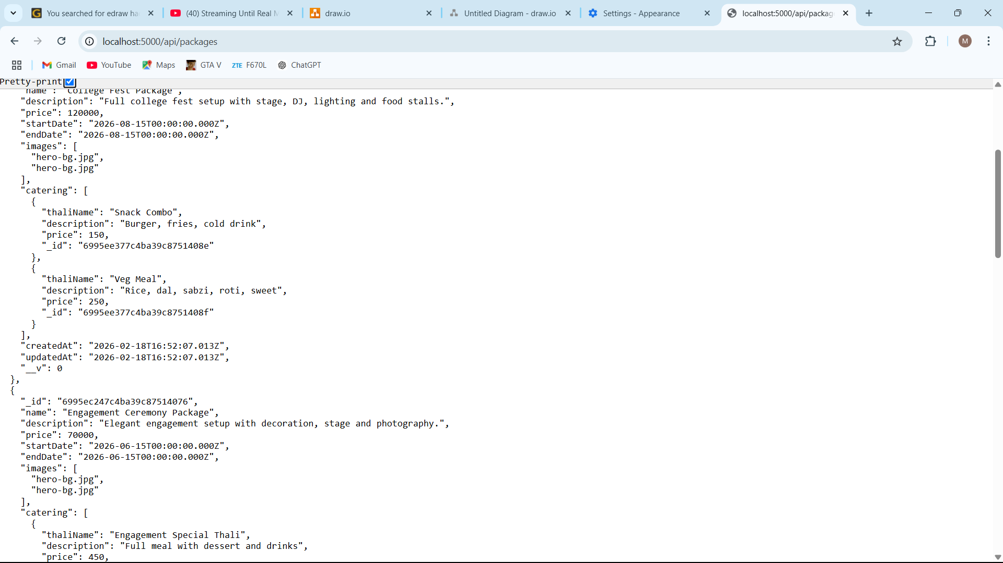

  - Frontend Design :

4.3.1 Home Page

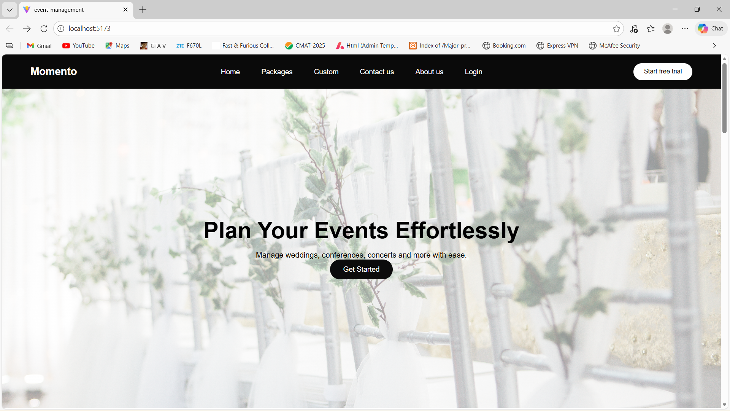

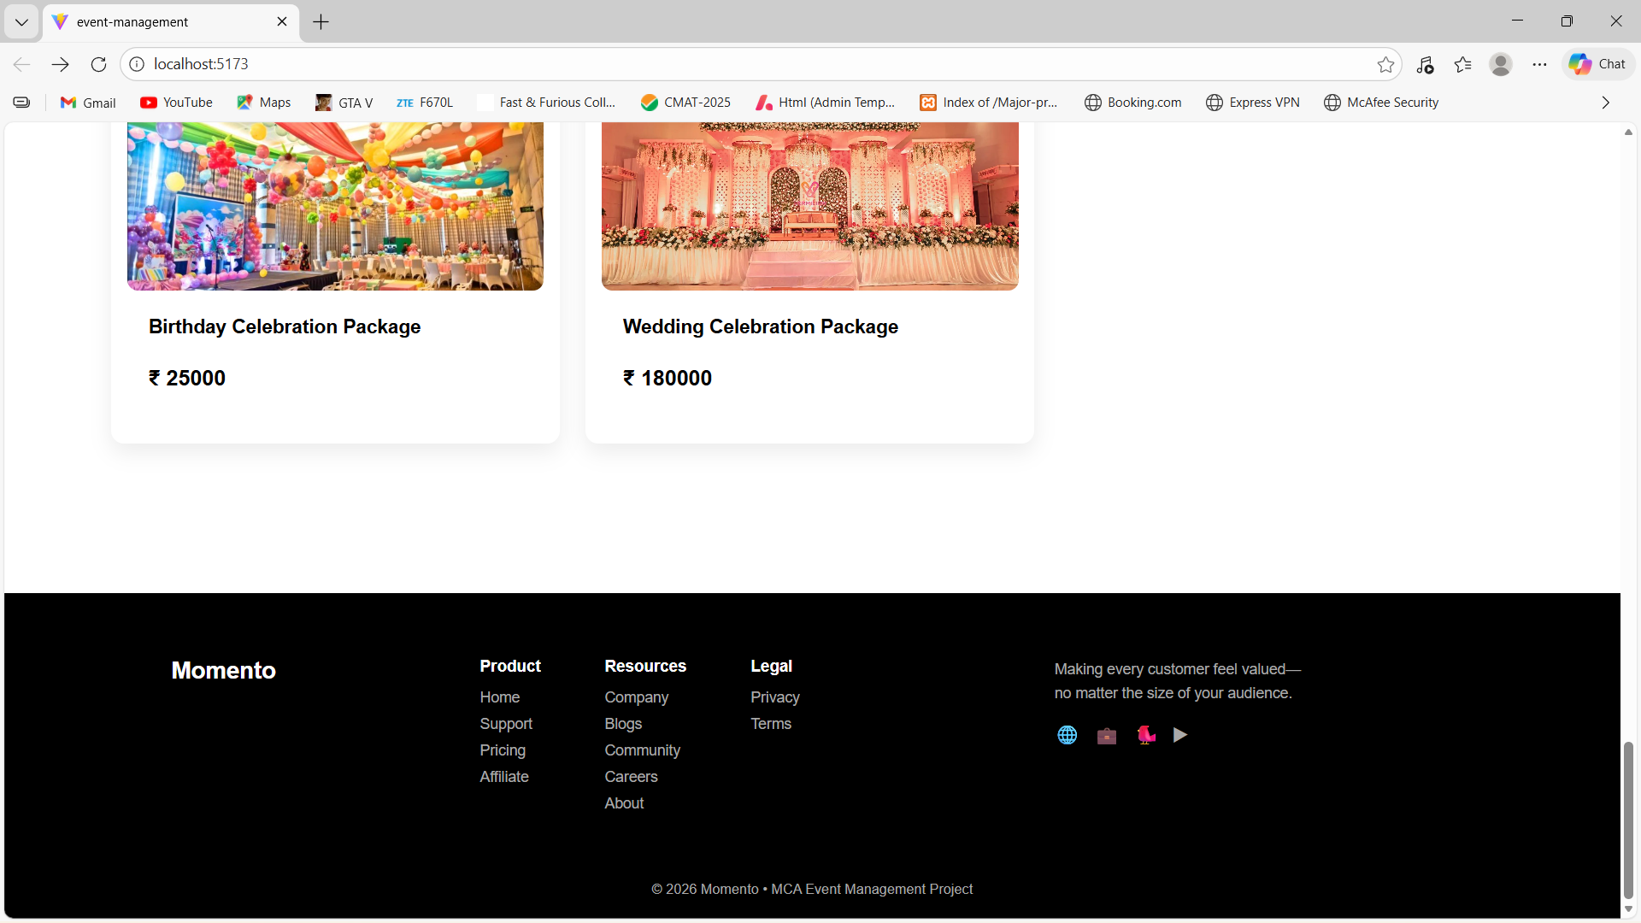

    - Recent Events :

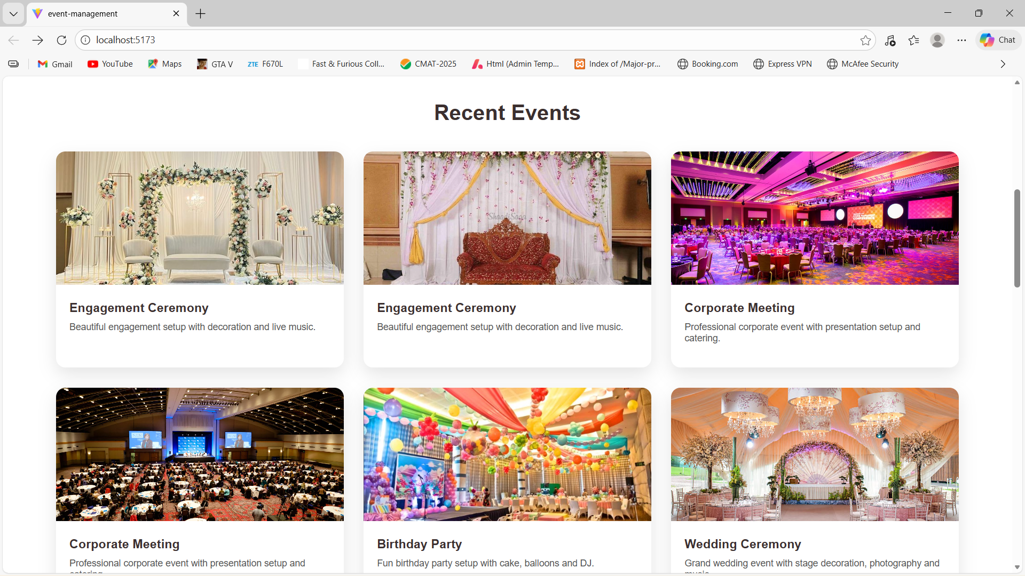

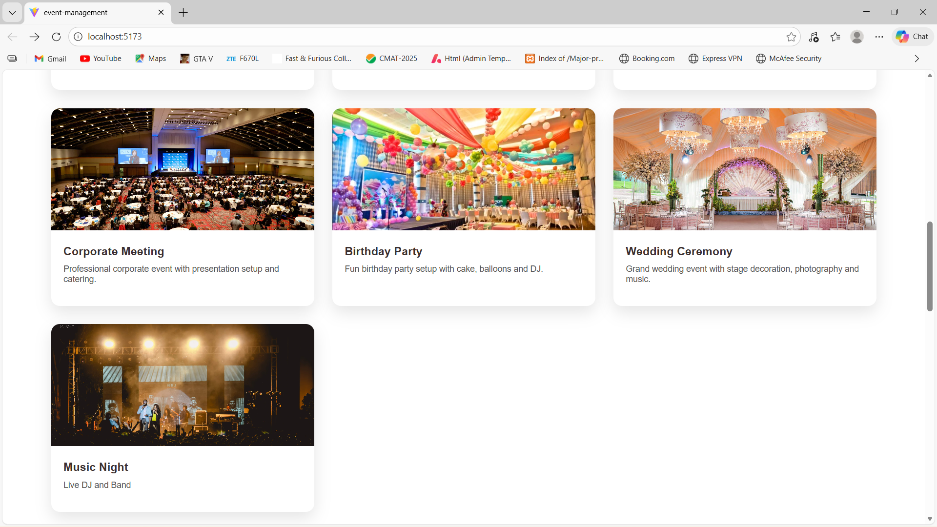

    - Package Display Page :

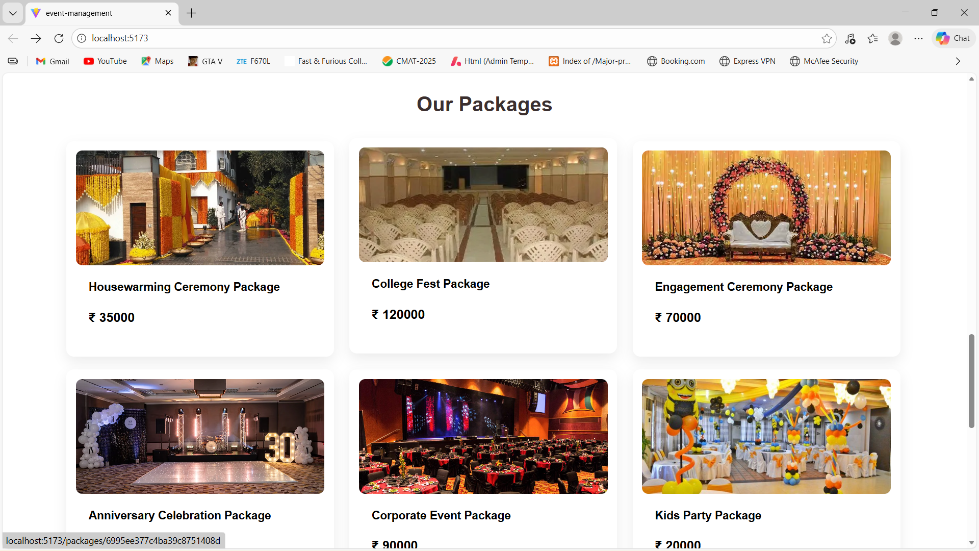

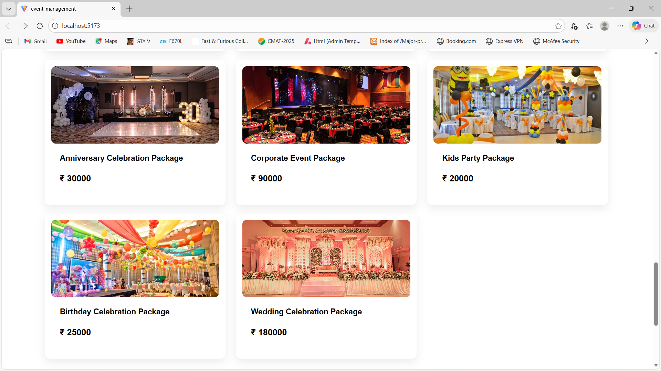

  - PackageDetail Page

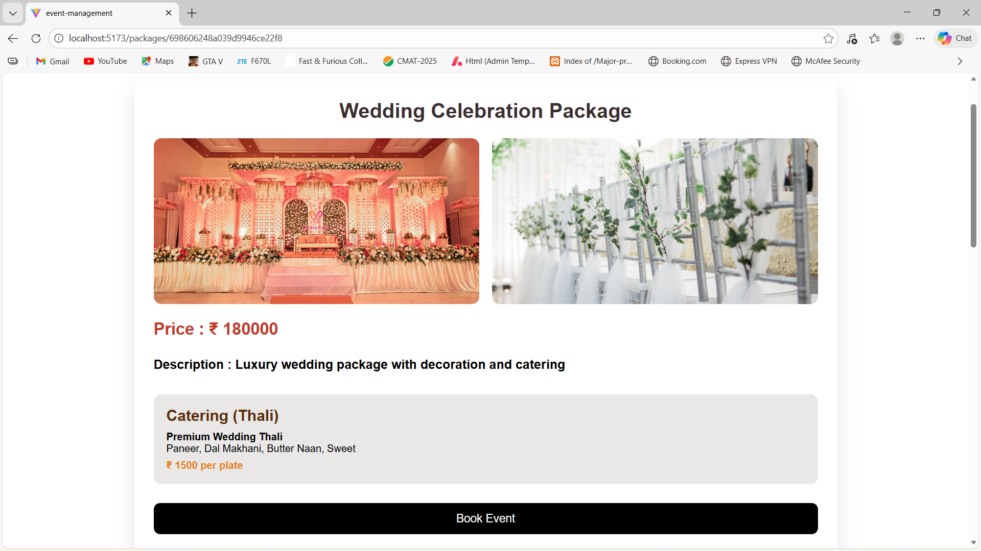

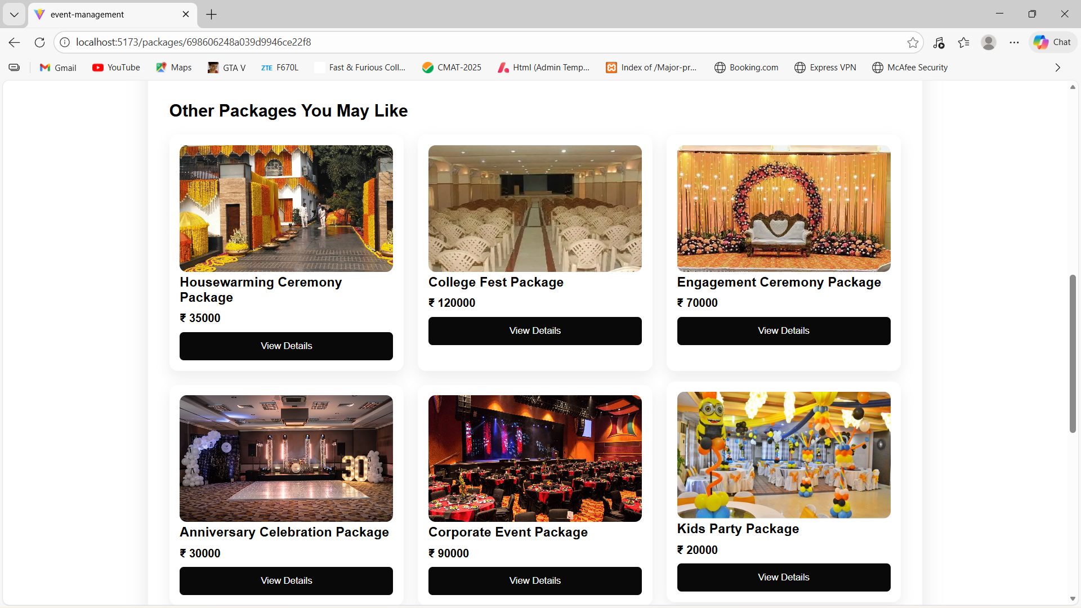

  - About Us Page :

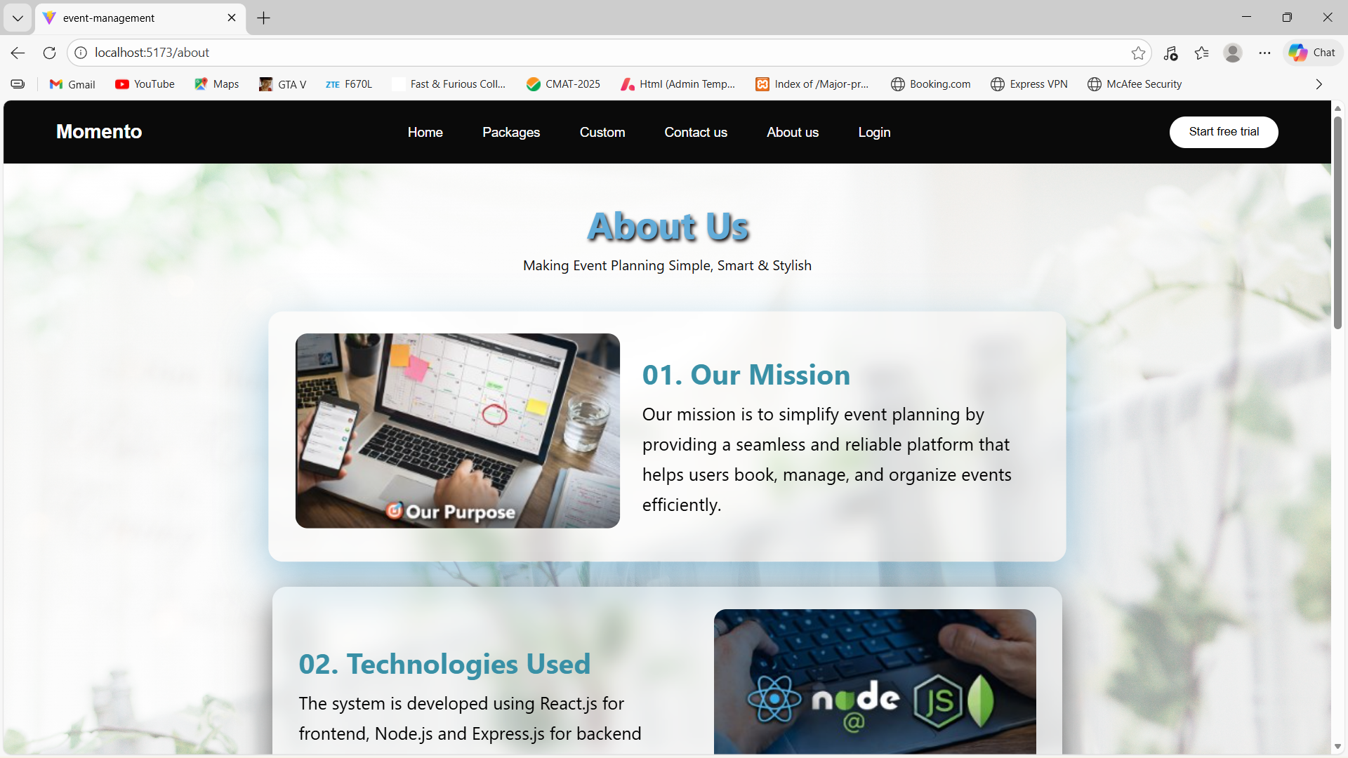

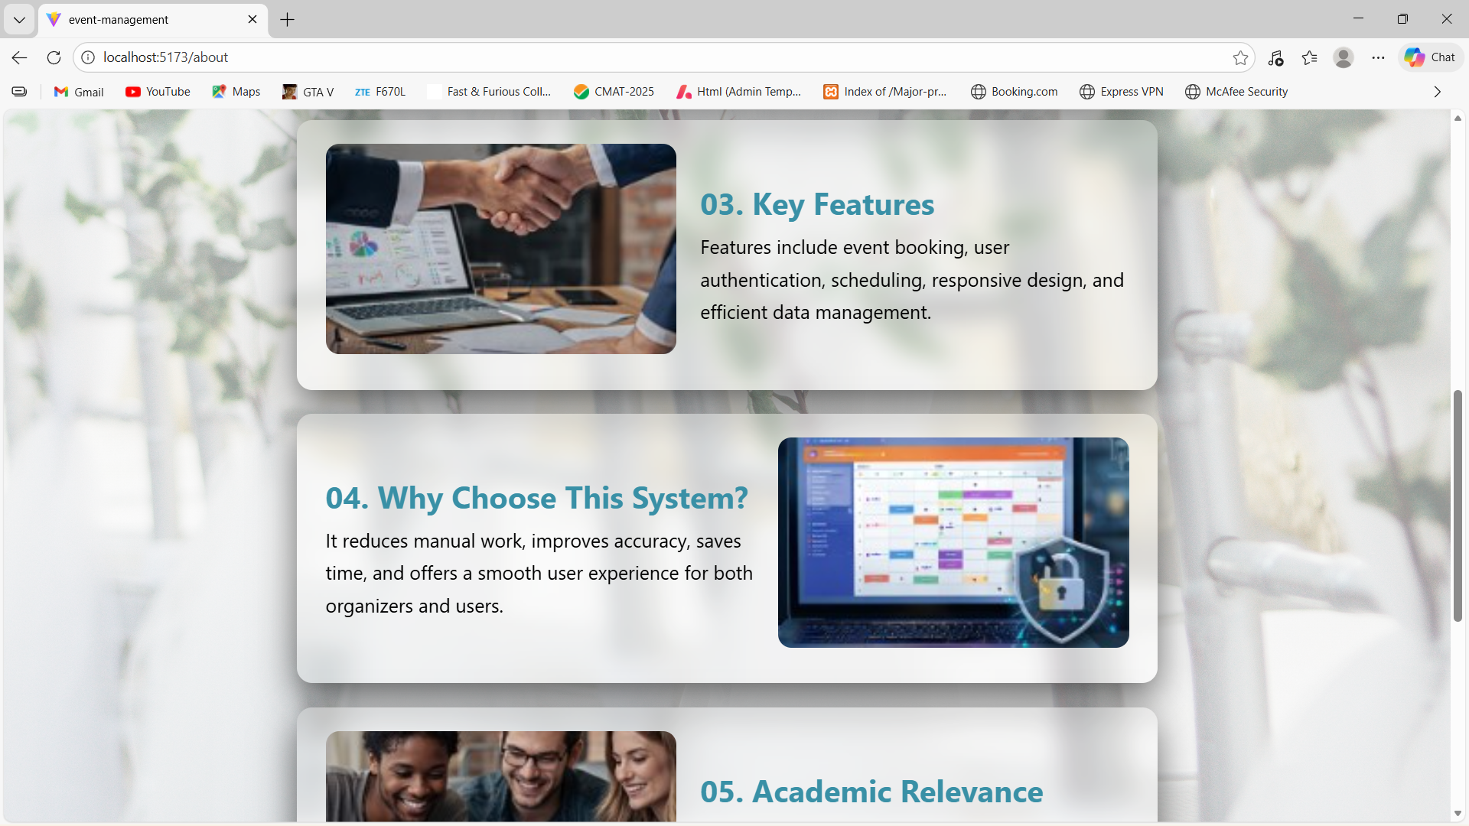

  - Contact Us Page :

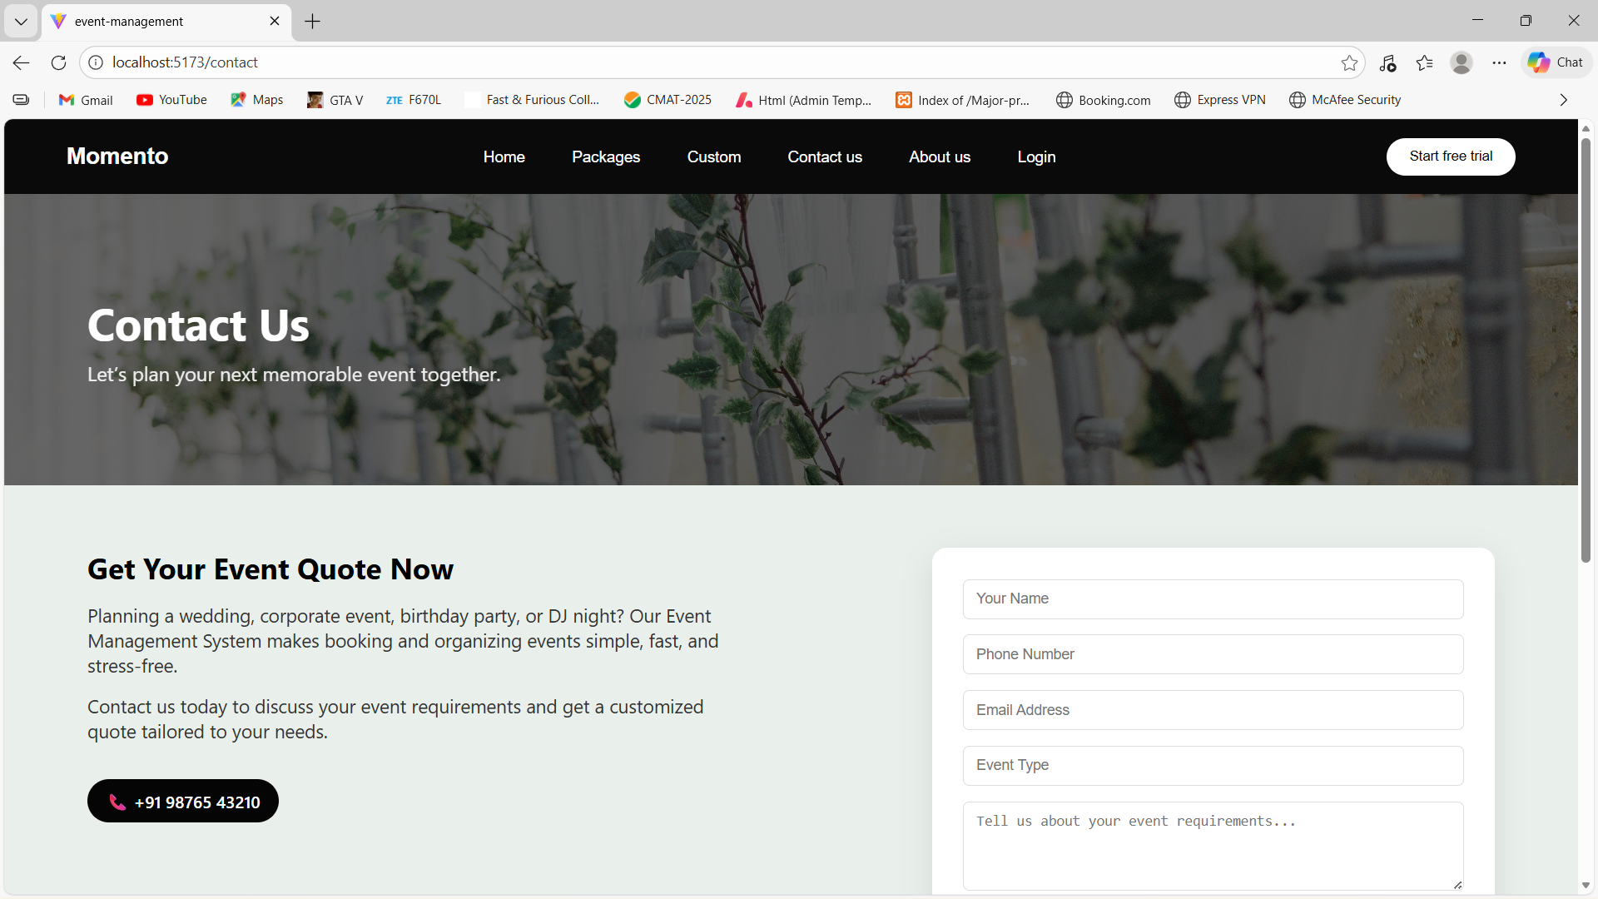

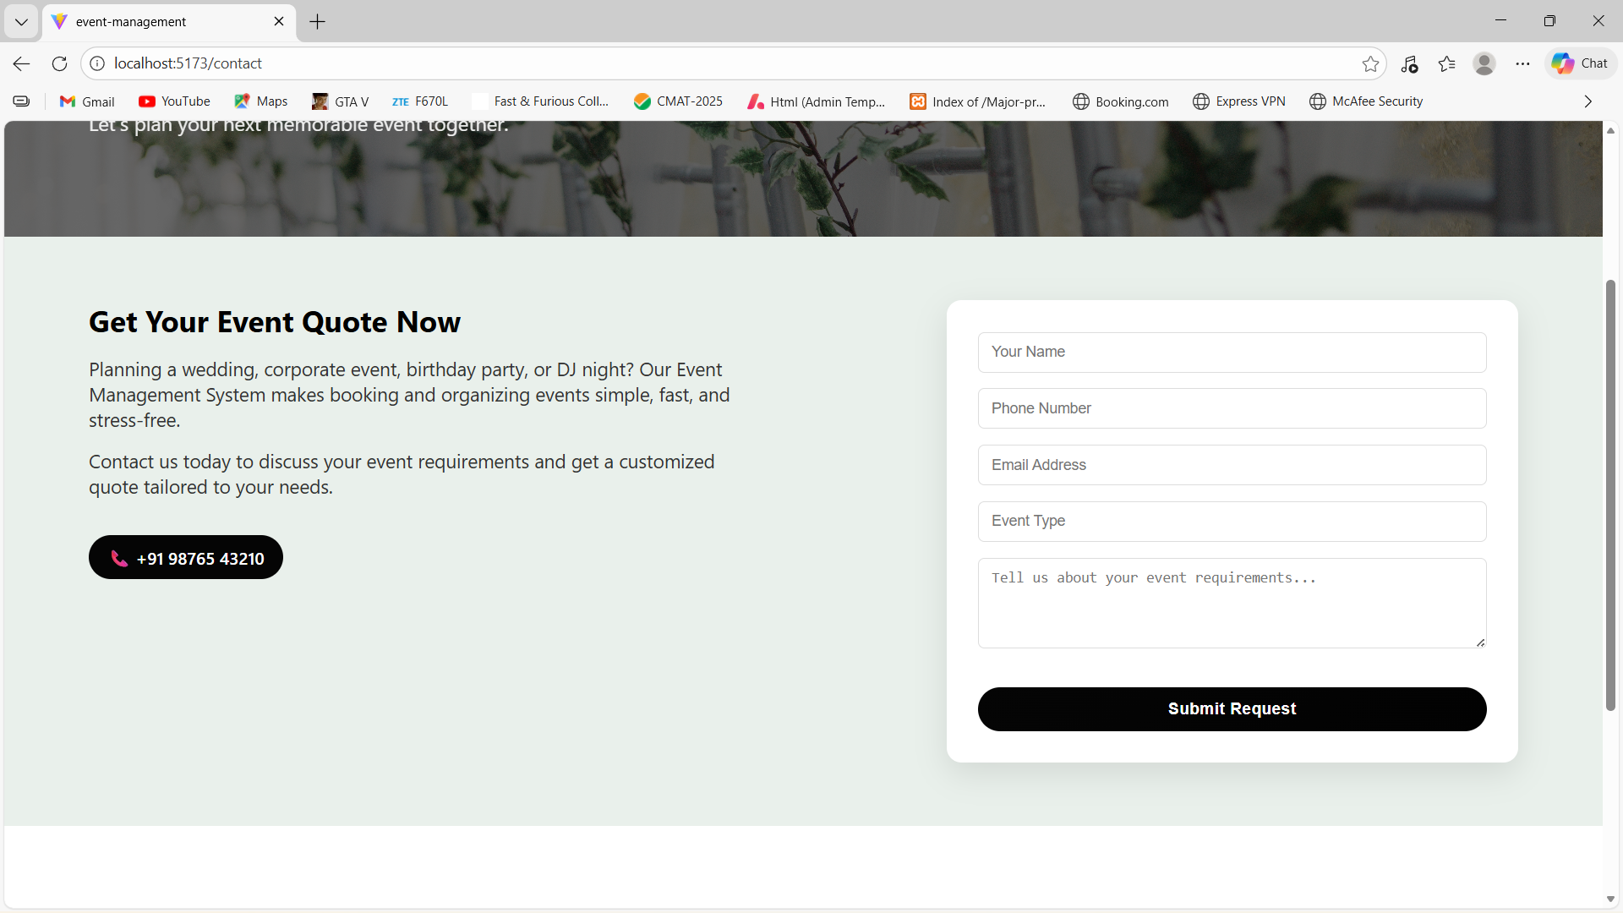

  - Login Page :

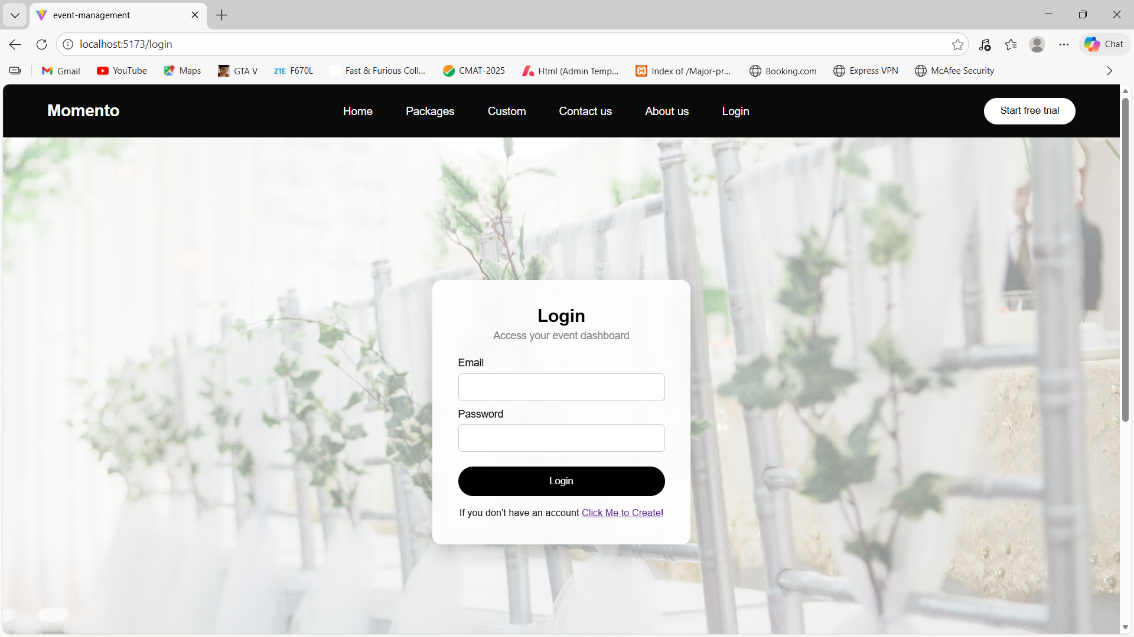

  - Register Page :

